

# Monetary policy: many targets, many instruments. Where do we stand?

Remarks given by

Mervyn King, Governor of the Bank of England

At the IMF Conference on ‘Rethinking Macro Policy II: First Steps and Early Lessons’, Washington DC

16 April 2013

I would like to thank Charlie Bean, Alex Brazier, Spencer Dale, Andy Haldane and Iain de Weymarn for helpful comments and suggestions in preparing these remarks; and in particular Tim Taylor who I regard as a co-author, although he is absolved of any errors in the current draft.

## Introduction

The past five years have been an extraordinary period for central banks. The breadth and scale of our operations have expanded in ways that were previously unimaginable as we responded to a crisis in the banking sector and the wider economy. In monetary policy, we have moved into uncharted territory. But has our notion of what central banks should do, and how, changed? Now is a good time to reflect on where we stand.

I want to focus my remarks on two areas. First, I want to draw out what have we learned about the objectives of monetary policy. Second, I want to reflect on the implications of the proliferation of instruments that have been used to meet those objectives.

## Objectives

For over thirty years the objective of central banks was clear. It was to set monetary policy to achieve long- run price stability. But the events of the past five years have raised questions about how central banks manage the trade-offs between price stability, output stability and financial stability in order to meet our overall macroeconomic objectives.

Throughout the era of inflation targeting, the importance of the trade-off between output and inflation stabilisation in the short term has been well understood. Monetary policy was seen as aiming at a target for inflation in the long run, which was to be achieved by bringing inflation back to target over a suitable time horizon so as to avoid excessive volatility of real variables such as output and employment. Optimal monetary policy was seen as a choice of how best to navigate the short-run trade-off while ensuring that the long-run objective was met.

Failure to deliver price stability is costly, as UK experience amply demonstrates. Chart 1 shows the variance of inflation and of the output gap in the UK, using quarterly data for two periods.1 Contrast the performance in the 35 years up to 1992 with the first 15 years of inflation targeting. Better policy can take some credit for this improvement, as the anchoring of inflation expectations led to a huge reduction in inflation volatility.

It was tempting to think that we had moved onto the ‘Taylor frontier’ – which maps feasible combinations of the smallest variances of the output gap and inflation. The Great Stability appeared to be a permanent break from earlier periods – periods when monetary policy exhibited more unpredictable behaviour and left the economy to the north-east of the Taylor frontier (Chart 2). And in one important sense it was – the dark days of double-digit inflation were consigned to the past.

1 The inflation measure used is the quarterly rate of increase of the GDP deflator, defined as the ratio of nominal GDP to real GDP. The output gap is estimated as the difference between the log of real GDP and the trend path of log GDP, derived using the HP-filter.

Source: ONS and Bank of England calculations.

But the Great Stability was not representative of a new normal. The variance of the output gap – though not inflation - has been much higher over the past five years as the financial crisis generated a deep recession (Chart 3). So what have we learned?

The banking and broader economic crisis has demonstrated that macroeconomic policy can face an additional trade-off between ensuring the soundness of the financial system in the medium term, and keeping output in line with potential output and inflation on target in the near term. Such a trade-off arises because financial vulnerabilities can build even while output is growing steadily and inflation is low and stable.

Let me give three examples of the sort of underlying mechanisms at play. First, persistent misperceptions of future spending power may generate a mix of demand that proves to be unsustainable. I believe this was an important factor underlying the crisis. Although output in deficit countries – like the UK – appeared to be growing at a sustainable rate, that gave a misleading impression of the sustainability of the Great Stability.

In fact the level of domestic demand was too high and the level of net exports correspondingly too weak. Second, as Hyman Minsky described, periods of stability encourage exuberance in credit markets, leading eventually to instability. And third, low short-term policy rates may encourage investors to take on more risk than they would otherwise accept as they ‘search for yield’.

It is arguable that monetary policy paid insufficient heed to the potential impact of such financial vulnerabilities. Financial shocks are costly because their effects can be too rapid for policy easily to offset, and because they hit potential supply so creating a trade-off between output and inflation. In other words, the Taylor frontier is less favourable (further from the origin), when account is taken of financial shocks, than we might have believed. Taking the entire period of inflation targeting – including the recent past – might give a more accurate indication of where this ‘Minsky-Taylor’ frontier lies than using data for the Great Stability period alone (Chart 4).

What implications does this have for monetary policy? Possibly none - if we can rely now on macroprudential tools to ensure financial sector resilience. But set those tools to one side for a moment. Monetary policy could be used to reach a point more like P in Chart 5, with less variation in the output gap and more variation in inflation than we have actually experienced over the past 20 years. Put another way, higher interest rates in the run up to the financial crisis might have reduced the impact of the subsequent bust, at the cost of below-target inflation and below-trend output before the crisis hit.2

2 A more detailed appraisal of this argument is contained in ‘Twenty years of inflation targeting’, a speech by Mervyn King (2012), available at [http://www.bankofengland.co.uk/publications/Pages/speeches/2012/606.aspx.](http://www.bankofengland.co.uk/publications/Pages/speeches/2012/606.aspx)

In practice new macroprudential tools and better micro-prudential supervision will improve the possibilities available to monetary policymakers. Having additional instruments in effect brings about a favourable shift in the Minsky-Taylor frontier (or surface) which defines the possibilities open to policymakers.3

Nevertheless, consistent with the new remit4 given to the Monetary Policy Committee by the UK Government last month, the experience of recent years suggests that there may be circumstances in which it is justified to aim off the inflation target for a while in order to moderate the risk of financial crises.

## Instruments

For institutions generally regarded as conservative or even hidebound, central banks have been remarkably innovative in their creation of new instruments during the crisis. Lowering official interest rates virtually to zero was extraordinary in itself. But the wholesale redesign of frameworks to supply liquidity to the banking system, the expansion of the monetary base by multiples of its pre-crisis level through the purchase of assets held by the non-bank private sector, and the involvement of central banks in risky credit easing operations have all raised serious questions about the role of central banks – and even challenged the idea of central bank independence.

Table 1 shows just how large has been the scale of central bank expansion. The monetary base has risen by unprecedented proportions as we tried to prevent a collapse of broad money and credit as happened in the US during the Great Depression and today in Greece. And central bank balance sheets have risen across the industrialised world, as shown in Table 2. That expansion has reflected both money creation through asset purchases and lending against collateral. All major central banks have created new ways to lend against collateral.5 Far from their image as conservative creatures, are central banks at risk of throwing their traditional caution to the wind and ignoring the limits on monetary policy?

Two limits are relevant in current circumstances. First, no matter how much liquidity is thrown at the banking system, lending and the economy will not recover if the banking system is inadequately capitalised and suffering from excessive leverage. That is why the Bank of England’s Financial Policy Committee has placed weight on the need for the weaker UK banks to raise capital. It is not surprising that the more

3 A social planner would use both instruments together to pick the welfare maximising point on the frontier / surface, and in the UK the Monetary Policy Committee is expected to work closely with the Financial Policy Committee which has the statutory power to deploy macro-prudential instruments.

4 The relevant passage in the Monetary Policy Committee’s remit states: “Circumstances may also arise in which attempts to keep

inflation at the inflation target could exacerbate the development of imbalances that the Financial Policy Committee may judge to represent a potential risk to financial stability. The Financial Policy Committee’s macro-prudential tools are the first line of defence against such risks, but in these circumstances the Committee may wish to allow inflation to deviate from the target temporarily, consistent with its need to have regard to the policy actions of the Financial Policy Committee. The full remit is available here: [http://www.hm-treasury.gov.uk/d/chx_letter_to_boe_monetary_policy_framework_200313.pdf.](http://www.hm-treasury.gov.uk/d/chx_letter_to_boe_monetary_policy_framework_200313.pdf)

5 Facilities introduced by the Bank of England have included the Discount Window Facility, the Special Liquidity Scheme, Extended

Collateral Term Repos, Extended Collateral Long Term Repos, and the Funding for Lending Scheme. The ECB initiated its Long Term Repo Operations. And Federal Reserve facilities include the Term Auction Facility, the Term Assert Backed Securities Loan Facility, the Primary Dealer Credit Facility, the Commercial Paper Funding Facility, the Term Securities Lending Facility, the ABCP Money Market Fund Liquidity Facility, the Money Market Investing Funding Facility, and the Term Discount Window Program.

strongly capitalised banks in the UK are expanding lending and the poorly capitalised banks are contracting lending.

Second, there are limits on the ability of domestic monetary policy to expand real demand in the face of the need for changes in the real equilibrium of the economy. I do not believe that the present problems in the United Kingdom stem only from a large negative shock to aggregate demand. In common with many other countries, our problems also reflect the underlying need to rebalance our economy, requiring a reallocation of resources both within and between nations. It is not simply a question of boosting aggregate demand, but of helping to bring about a shift to a new equilibrium. That in turn implies the need for both large changes in relative prices, especially between tradable and non-tradable goods and services, and a shift in the relative levels of domestic demand at home and overseas. There are, therefore, limits on what any one country’s domestic monetary policies can achieve without the support of others.

Despite these limits, circumstances have demanded that central banks take extraordinary measures. Such measures can risk moving into territory more normally associated with fiscal policy and, in doing so, put at risk their hard-won independence. There are, it seems to me, three threats to central bank independence.

First, there is the risk of appearing to promise too much or allowing too much to be expected of us. With constraints on other policy instruments, central banks are seen as “the only game in town”. But failure to make clear the limits to monetary policy risks disillusionment with central banks and the inevitable political pressure on them that would follow.

Second, at the zero lower bound there is no clear distinction between monetary and fiscal policy. But it is still important to ensure that central banks do not take on to their balance sheets risks to the taxpayer that are properly matters that should be decided by elected politicians. To ensure price stability in the long run it is vital to maintain the operational independence of a central bank. Any decisions that put taxpayers’ money at risk must be made by finance ministries, and central banks must protect their balance sheets by imposing appropriate haircuts on collateral, and avoiding the purchase of risky private-sector assets.

Third, and important even when we move away from the zero lower bound, the expansion of central bank responsibilities to include macroprudential policy and, in the case of the Bank of England, responsibility for regulating the banking system, has made independence much harder to define. The deployment of responsibilities outside monetary policy cannot be divorced from the government in the same way as is possible for monetary policy. For example, in the area of financial stability and banking supervision, there will be times when public funds may be put at risk when rescuing or resolving a failing institution – and that decision is properly one for the finance ministry. It is far from straightforward for a central bank governor to be completely independent in terms of monetary policy, somewhat independent in terms of financial stability, and not at all independent in terms of operations that risk taxpayers’ money.

The financial crisis has challenged our understanding of the objectives of monetary policy and exposed its limits. And, through the proliferation of instruments and resulting increase in responsibilities, it has complicated the question of central bank independence. So how should we respond to this more complex environment? We must keep sight of three important principles. First, although they should be realistic about what can be achieved, it is right that elected politicians and parliaments decide on the objectives of policy. Second, as we learned in the 1970s, if the central bank is to achieve price stability – its fundamental role – it must be sufficiently independent. And third, in order to protect that independence, its limits should be very clearly circumscribed, and we should be exceptionally careful with decisions that put public funds at risk.

The challenge remains, as it was twenty years ago, to make “constrained discretion” work in practice. But it has got harder.

# Chart 1: UK inflation and output gap variances

3



1958‐1992

1993‐2007

2

**Inflation variance**

1

0

0 1 2 3

**Output gap variance**

**Chart 2: The UK’s pre-crisis trade-off?**

3



Stylised ‘Taylor frontier’

1958‐1992

1993‐2007

2

**Inflation variance**

1

0

0 1 2 3

**Output gap variance**

**Chart 3: The ‘Great Stability’ and crisis periods**

3



1958‐1992

2008‐2012

1993‐2007

2

**Inflation variance**

1

0

0 1 2 3

**Output gap variance**

**Chart 4: The true trade-off for the UK over 20 years?**

3



1958‐1992

1993‐2012

2008‐2012

1993‐2007

2

**Inflation variance**

1

0

0 1 2 3

**Output gap variance**

**Chart 5: A preferable outcome?**

3



1958‐1992

**P**

1993‐2012

2008‐2012

1993‐2007

2

**Inflation variance**

1

0

0 1 2 3

**Output gap variance**

**Table 1: Monetary base**

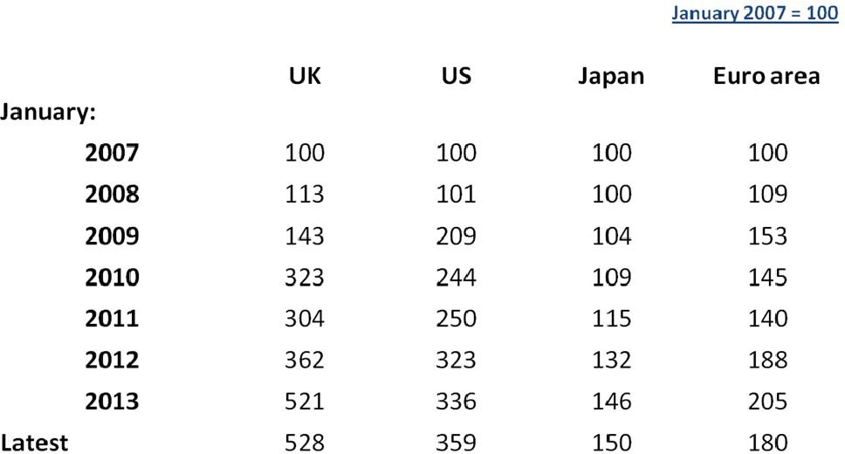



**Table 2: Size of central bank balance sheets**

